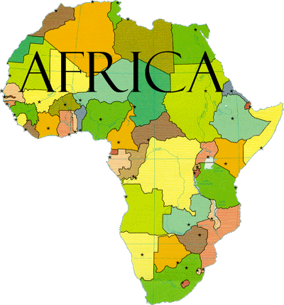
A Look at African Countries
- Sketch a large outline of the country you have been assigned and cut it out.
- Using https://www.cia.gov/library/publications/the-world-factbook/ find the following information and put the appropriate symbols in your country.

- Name of Country- Put in the middle of your country cut-out
- Flag- Sketch or print a small flag of your country
- Population- Stick figure of a person and the number (People and Society)
- Languages Spoken- Write out the language(s) (People and Society)
- Area per sq. km- Picture of a square and the number inside it (Geography)
- Government Type- Picture of your choosing (Government)
- Exports and Imports- A picture for each that is appropriate for your country (Economy)

- % of Population 0-14 yrs- Make a pie graph (People and Society)
- Literacy Rate- Book with a number in it (People and Society)
- Life Expectancy- Picture of person with appropriate age (baby, child, adult, elderly person) with the age on its shirt (People and Society)

- Per Capita GDP- Person with dollar amount under it (Economics)
- % Urban Population- City building with percentage on or near picture (People and Society)

- Birth Rate- Baby bottle with number in or near it (People and Society)
- Infant Mortality Rate- Picture of your choosing (People and Society)
- HDI- arrow indicating high (arrow up), Medium (arrow to the side), or low (arrow down). Write the HDI number in the arrow. Use website and 2013 numbers: http://hdr.undp.org/en/content/human-development-index-hdi-table
Things to Keep in Mind:
Neatness Counts!

-The Human Development Index- (commonly abbreviated HDI) is a summary of human development around the world and implies whether a country is developed, still developing, or underdeveloped based on factors such as life expectancy, education, literacy, gross domestic product per capita. The results of the HDI are published in the Human Development Report, which is commissioned by the United Nations Development Program and is written by scholars, those who study world development and members of the Human Development Report Office of the UNDP.

0.800 or higher = High HDI
0.500-0.800 = Medium HDI
Below 0.500 = Low HDI

- Per Capita GDP- A measure of the total output of a country that takes the gross domestic product (GDP) and divides it by the number of people in the country. The per capita GDP is especially useful when comparing one country to another because it shows the relative performance of the countries. A rise in per capita GDP signals growth in the economy and tends to translate as an increase in productivity.

**Focus on the information you find about your country while you do this activity. You will be comparing it to the United States and other African countries**

